**Circuitry Part**

**COMPONENTS**

● Ultrasonic sensor(HC-SR04): For the detection of the human body.

● Arduino Board: To feed the program to perform all the action in the process of sanitization.

● Li-Po battery (12V): To provide Power to the circuit and all other electronic components.

● Mist-Atomizer: For conversion of liquid sanitizer in mist or fog form.

● Wifi-Module(ESP8266): For connecting the SVM with mobile phone for power ON/OFF

purpose.

● Container: To store the sanitizer.

● Jumper Wires : For connecting the circuitry of SVM.

**Working of Sanitizer Vending Machine**

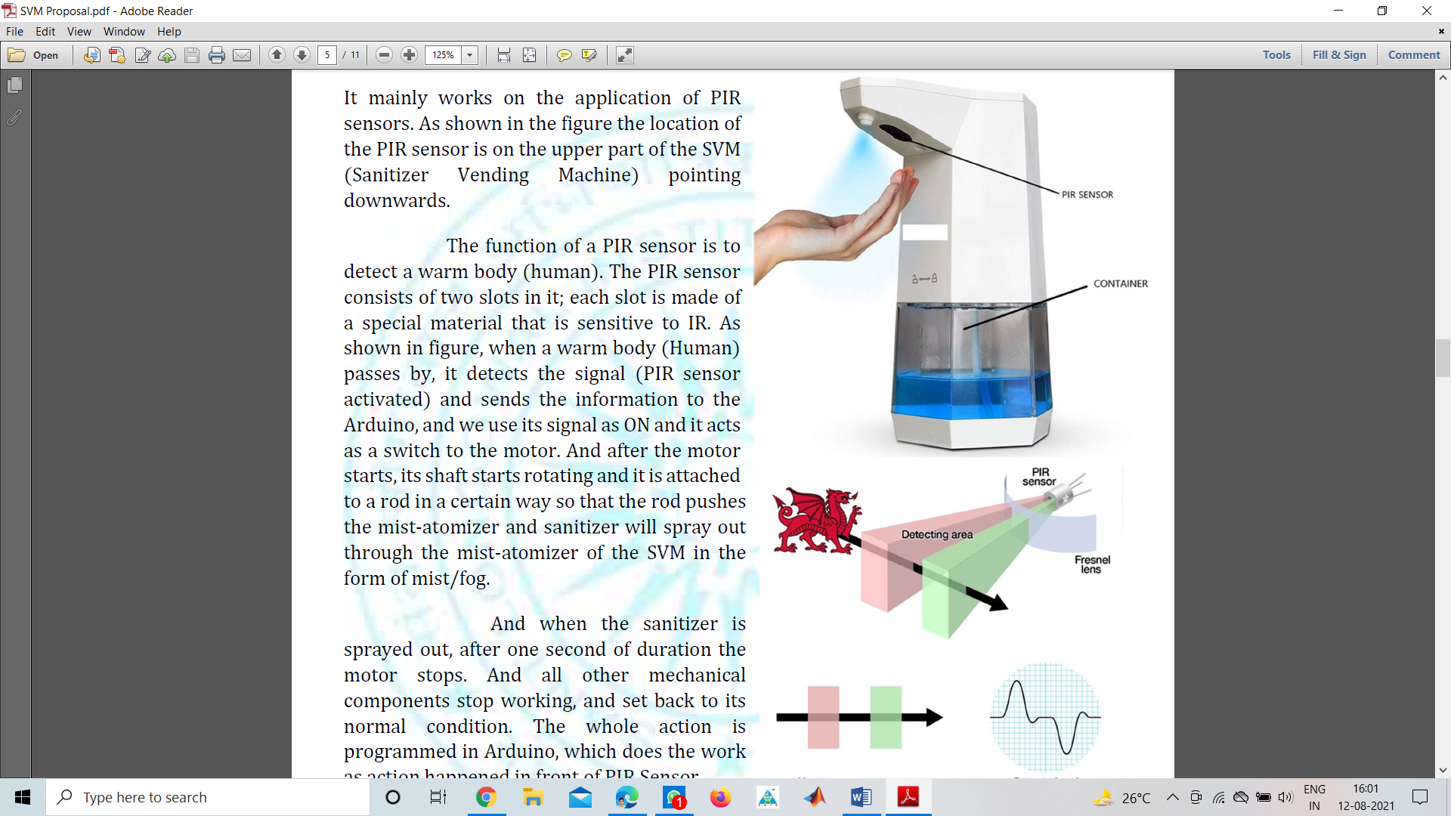It mainly works on the application of Ultrasonic sensors. As shown in the figure the location of the Ultrasonic sensor is on the upper part of the SVM (Sanitizer Vending Machine) pointing downwards.

The function of the Ultrasonic Sensor is to detect the motion. When any hand comes in front of the Ultrasonic Sensor detects motion and send signal to the Arduino. After that, the Mist Atomizer gets the power from the Arduino and starting to release the mist in the form of fog.

And when the sanitizer is sprayed out, after 5-7 seconds of duration the Mist Atomizers stops. Also, all other mechanical and electronics components stop working, and set back to its normal condition. The whole action is programmed in Arduino, which does the work as action(motion) happened in front of Ultrasonic Sensor Sensor.

We also use Wi-Fi module for hands free power ON/OFF operation through mobile phone. So there is no need to touch the SVM even for ON/OFF purpose.

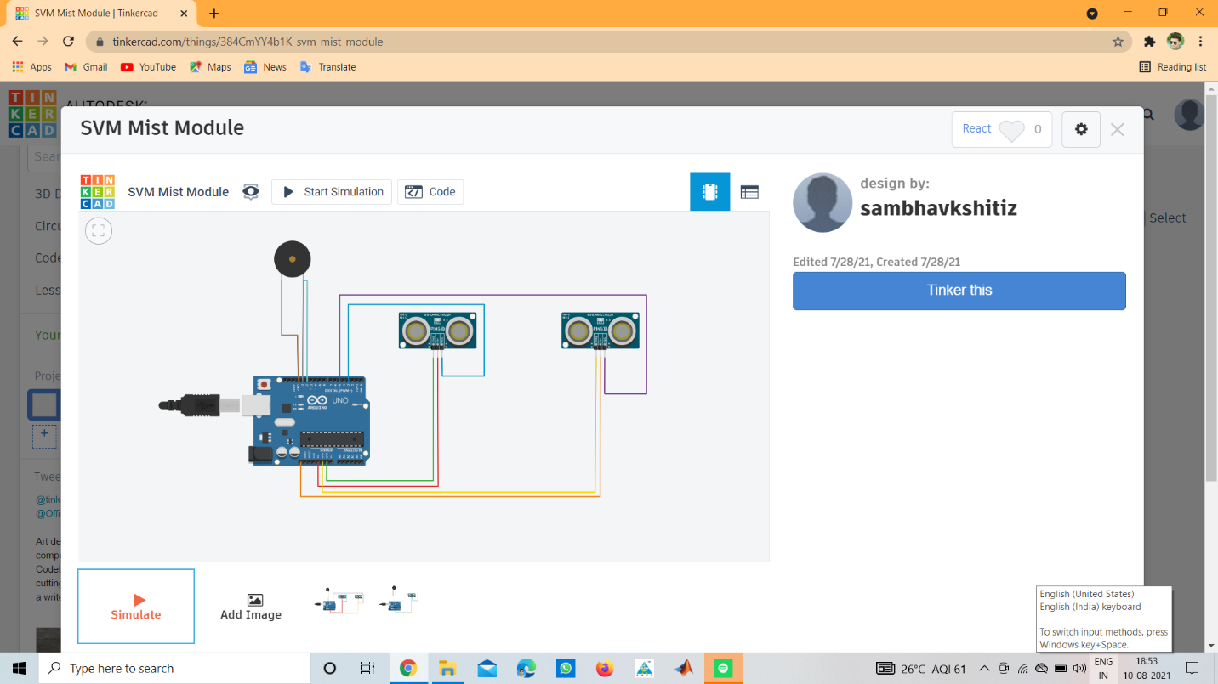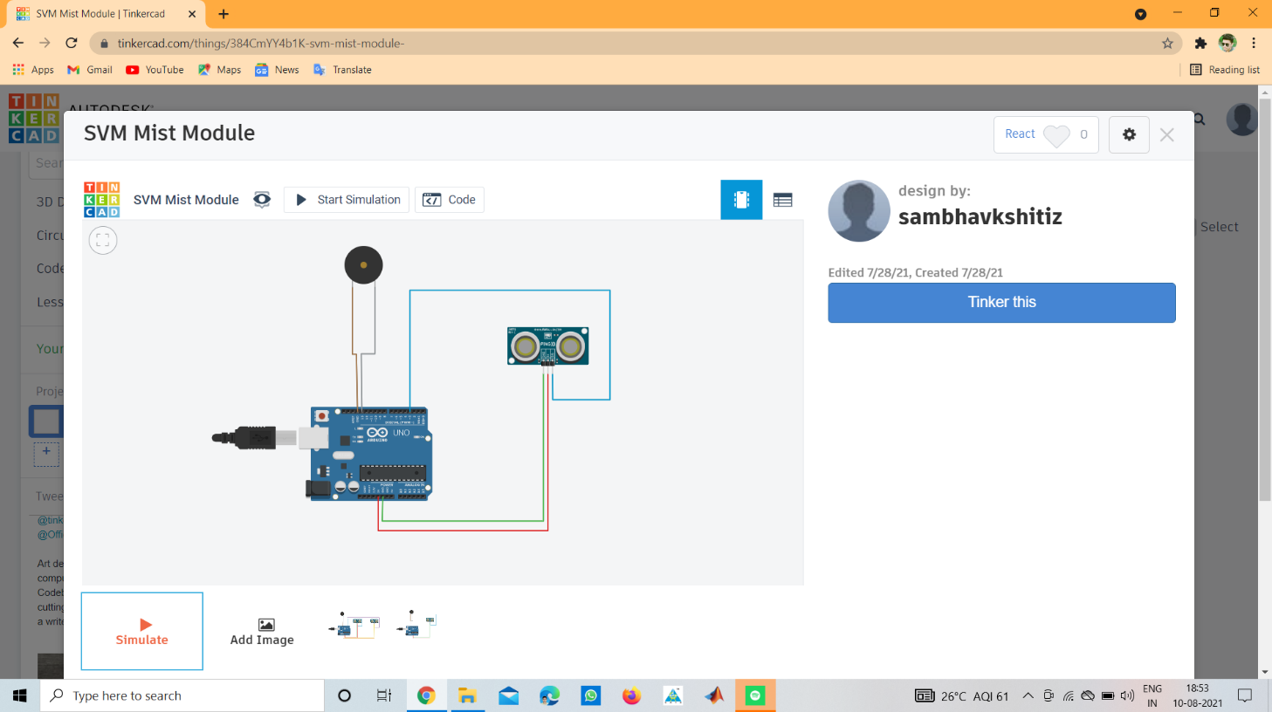The above shown figures shows the circuit diagram of the internal circuit diagram of SVM.

In the fig., shown there are two circuits. The first circuit is basically operating with single Ultrasonic Sensor and the second one is operating with two ultrasonic sensors. The main purpose for using two Ultrasonic Sensor is to increase the input voltage of the Mist Atomizer and also get more sanitizer in the form of mist.

**Description of Components**

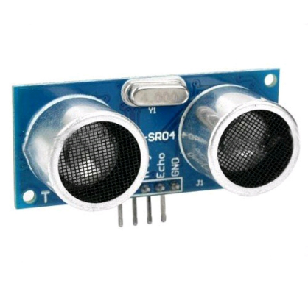**Ultrasonic Sensor**

This HC-SR04-Ultrasonic Range Finder is a very popular sensor which is found in many applications where it requires to measure distance and detect the objects. The module has two eyes like projects in the front which forms the Ultrasonic transmitter and Receiver.

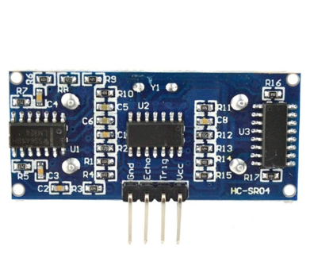The HC-SR04 ultrasonic sensor uses sonar to determine the distance to an object like bats or dolphins do. This Ultrasonic Sensor module is a transmitter, a receiver and a control circuit in one single pack!! It has very handy and compact construction. It offers excellent range accuracy and stable readings in an easy-to-use package. Its operation is not affected by sunlight or black material like Sharp rangefinders are (although acoustically soft materials like cloth can be difficult to detect).

The Trigger and the Echo pins are the I/O pins of this module and hence they can be connected to the I/O pins of the microcontroller/Arduino. When the receiver detects return wave the Echo pin goes high for a particular amount of time which will be equal to the time taken for the wave to return back to the sensor.

Ultrasonic Ranging Module HC-SR04 provides 2cm-400cm non-contact distance or motion sensing capabilities; ranging accuracy up to 3mm.

**Wiring:-**

* +5V(positive)
* Trig(control)
* Echo(receive)
* GND(negative)

**Features :-**

* Measures the distance within a wide range of 2cm to 400cm
* Stable performance
* Accurate distance measurement
* High-density
* Small blind distance

**Specifications:-**

|  |  |
| --- | --- |
| **Model** | HC-SR04 |
| **Operating Voltage (VDC)** | 5 |
| **Average Current Consumption (mA)** | 2 |
| **Frequency(Hz)** | 40000 |
| **Sensing Angle** | 15Â° |
| **Max. Sensing Distance (cm)** | 450 |
| **Weight (gm)** | 9 |
| **Sensor Cover Dia. (mm)** | 16 |
| **PCB Size ( L x W ) mm** | 45 x 20 |

**Arduino Uno**

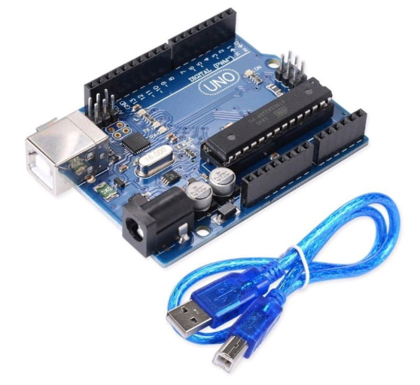The Arduino Uno R3 with Cable is a microcontroller board based on the ATmega328 (datasheet). It has 14 digital input/output pins (of which 6 can be used as PWM outputs); 6 analog inputs, a 16 MHz ceramic resonator, a USB connection, a power jack, an ICSP header, and a reset button.

It contains everything needed to support the microcontroller; simply connect it to a computer with a USB cable or power it with an AC-to-DC adapter or battery to get started.

**Specifications:-**

|  |  |
| --- | --- |
| **Model Type** | UNO Rev R3 |
| **Microcontroller Chip** | ATmega328 |
| **Operating Voltage (VDC)** | 5 |
| **Input Voltage(Recommended)** | 7-12V |
| **Input Voltage (limit)** | 6-20V |
| **Analog I/O Pins** | 6 |
| **Digital I/O Pins** | 14 (of which 6 provide PWM output) |
| **PWM Digital I/O Pins** | 6 |
| **DC Current per I/O Pin (mA)** | 40 |
| **DC Current for 3.3V Pin (mA)** | 50 |
| **Clock Speed** | 16 MHz |
| **SRAM (KB)** | 2 |
| **EEPROM** | 1 KB (ATmega328) |
| **Flash Memory** | 32 KB |
| **On Board LEDs** | On/Off, L (PIN 13), TX, RX |
| **Dimensions in mm (LxWxH)** | 75 x 54 x 12 |
| **Weight (gm)** | 28 (without cable) 54 (with cable) |

**Mist Atomizer**

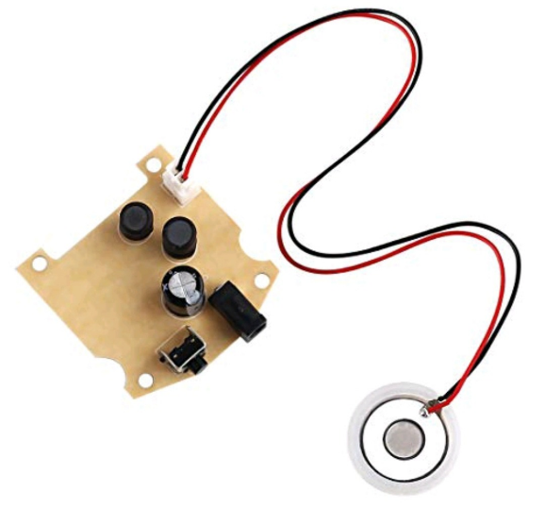This DC 5V Ultrasonic Humidifiers Power Circuit Board with Atomizing Chip Moisture Film Humidification atomization machine is suitable for the atomization plate tablet with a diameter of 20mm. This Ultrasonic Humidifier Piezoelectric Transmitter module works on the principle of cavitation produced by sound waves. Just provide the DC 3-12V power supply it will turn into a mini ultrasonic atomizer.

As sound waves contain compression and rarefaction. Due to extremely rapid movement, water droplets can no longer sustain their liquid state and gets converted into vapor immediately. This vibration is produced by a piezoelectric filament.

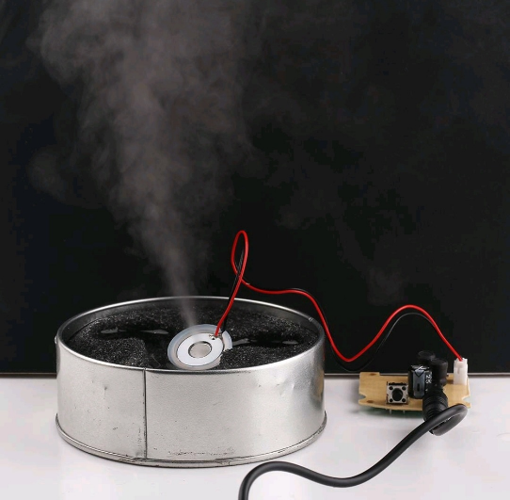**The Ultrasonic Principle of Operation**

A piezoelectric transducer immersed in a water bed, converts a high frequency, electronic signal into a high-frequency mechanical oscillation. As the oscillation speed is increased to a level where the water particles can no longer follow the oscillating surface, a momentary vacuum and strong compression occur, leading to the explosive formation of air bubbles (cavitation). At cavitation, broken capillary waves are generated, and tiny (1-micron diameter) droplets break the surface tension of the water and are quickly dissipated into the air, taking vapor form and absorbed into the air stream.

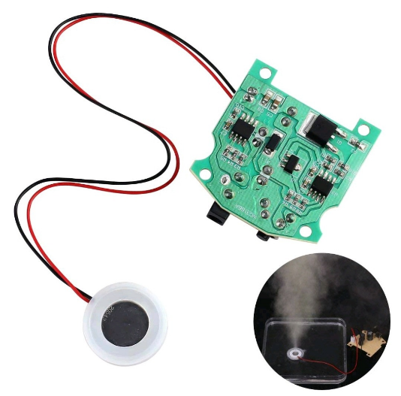**Features:**

* Low noise operation.
* Small fog particles.
* Long operation life.
* High stability.
* Driving Voltage: DC 3-12V.
* High Conversion Efficiency.
* Low Impedance Stable Waveform.
* Low Dielectric Loss.
* Strong Corrosion Resistance.
* Applications: for high-end toys, micro humidifier, etc. 113±3 KHz 3000±15% ρF .

**Specifications:-**

|  |  |
| --- | --- |
| **Driving Voltage ( V DC)** | 3 ~ 12 |
| **Operating Temperature (Â°C)** | -30 ~ +85 |
| **Operating Frequency** | 113Â±3KHz |
| **Rated Power** | 2.5W (normal use 1.5W) |
| **Oscillator Diameter (mm)** | 20 |
| **Oscillator Cable Length (mm)** | 70 |
| **Length (mm)** | 41.5 |
| **Width (mm)** | 38 |
| **Height (mm)** | 13.5 |
| **Weight (gm)** | 10 |

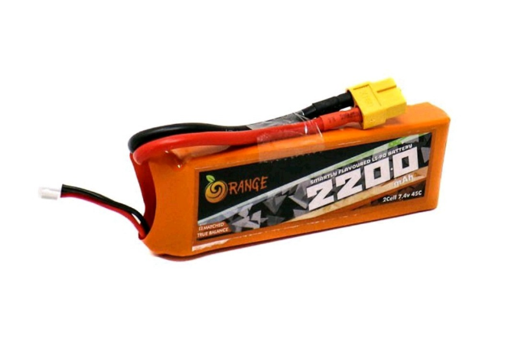**Li-Po Battery**

Orange 2200mAh 2S 45C Lithium polymer battery Pack (Li-Po) batteries are known for performance, reliability and price. It’s no surprise to us that Orange Lithium polymer packs are the go-to pack for those in the know. Orange batteries deliver the full rated capacity at a price everyone can afford.

Orange 2200mAh 2S 45C Lithium polymer battery Pack (Li-Po) batteries are equipped with heavy-duty discharge leads to minimize resistance and sustain high current loads. Orange batteries stand up to the punishing extremes of aerobatic flight and RC vehicles. All Orange Lithium Polymer batteries packs are assembled using IR matched cells.

Note: The battery dimensions and weight may have ±2% error.

**Safety Precautions :**

* Avoid over-charging or over-discharging the batteries.
* Do not put it beside the high-temperature condition.
* Don’t throw it into the fire or Water

**Features :-**

* The Orange Li-Po battery has matched resistance.
* Good Temperature Control.
* Minimum weight in Class.

**Specifications :-**

|  |  |
| --- | --- |
| **Model No.** | ORANGE 2200/3S-30C |
| **Capacity (mAh)** | 2200 |
| **Weight (gm)** | 175 |
| **Output Voltage (VDC)** | 11.1 |
| **Charge Rate (C)** | 1 ~ 3 |
| **Discharge Plug** | XT-60 |
| **Balance Plug** | JST-XH |
| **Length (mm)** | 106 |
| **Width (mm)** | 34 |
| **Height (mm)** | 23 |
| **Max. Burst Discharge (C)** | 60C(132.0A) |
| **Max. Charge Rate** | 5 C |
| **Max. Continuous Discharge** | 30C(66.0A) |

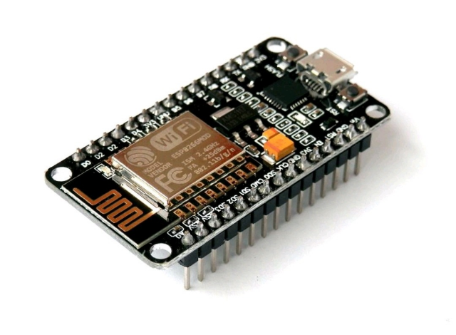**Wi-Fi Module (ESP8266)**

The ESP8266 NodeMCU CP2102 board has ESP8266 which is a highly integrated chip designed for the needs of a new connected world. It offers a complete and self-contained Wi-Fi networking solution, allowing it to either host the application or to offload all Wi-Fi networking functions from another application processor.

ESP8266 has powerful on-board processing and storage capabilities that allow it to be integrated with the sensors and other application-specific devices through its GPIOs with minimal development up-front and minimal loading during runtime. Its high degree of on-chip integration allows for minimal external circuitry, and the entire solution, including the front-end module, is designed to occupy minimal PCB area.

The ESP8266 NodeMCU development board - a true plug-and-play solution for inexpensive projects using Wi-Fi. The module arrives pre-flashed with NodeMCU firmware so they're ready to go - just install your USB driver (below). ESP-12 Lua Nodemcu WIFI Dev Board Internet Of Things board contains a full ESP8266 WiFi module with all the GPIO broken out, a full USB-serial interface, and a power supply all on the one breadboard-friendly package.

This board is pre-flashed with NodeMCU - a Lua-based firmware for the ESP8266 which allows easy control via a neat scripting language - Lua - so you're ready to go in just a few minutes.

The ESP-12 Lua NodeMCU WIFI Development Board Internet Of Things with ESP8266 is an all-in-one microcontroller + WiFi platform that is very easy to use to create projects with WiFi and IoT (Internet of Things) applications.

The board is based on the highly popular ESP8266 WiFi Module chip with the ESP-12 SMD footprint. This WiFi development board already embeds in its board all the necessary components for the ESP8266 (ESP-12E) to program and upload code. It has a built-in USB to serial chip upload codes, 3.3V regulator, and logic level converter circuit so you can immediately upload codes and connect your circuits.

**Features :-**

* 11 b/g/n Wi-Fi Direct (P2P), soft-AP.
* Integrated TCP/IP protocol stack.
* Use CH340G to replace the CP2102.
* Open-source, Interactive, Programmable, Low cost, Simple, Smart, WI-FI enabled
* Arduino-like hardware IO.
* Integrated low power 32-bit CPU.
* Advanced API for hardware IO, which can dramatically reduce the redundant work for configuring and manipulating hardware.
* Code like Arduino, but interactively in Lua script.
* Nodejs style network API.
* Event-driven API for network applications, which facilitates developers writing code running on a 5mm*5mm sized MCU in Nodejs style.
* Greatly speed up your IOT application developing process.
* Lowest cost WI-FI

**Specifications:-**

|  |  |
| --- | --- |
| **Serial/USB Chip** | CP2102 |
| **Output Power(dBm)** | 19.5 @802.11b Mode |
| **Flash Memory(Mb)** | 4 |
| **Support** | SDIO 1.1/2.0, SPI, UART |
| **Length (mm)** | 49 |
| **Width (mm)** | 24 |
| **Height (mm)** | 13 |
| **Weight (gm)** | 8 |